LOCAL HOME TUTOR FINDER
@CREATIVITY THINK (9483175986/7019689991)

ABSTRACT:
Local Home Tutor Finder is a dynamic web-based platform designed to connect students and parents with qualified local tutors. The system simplifies the process of finding subject-specific tutors based on filters like location, fees, experience, availability, and reviews. The platform also supports direct communication, booking management, and rating systems to ensure transparency and quality. Built using Django REST Framework for the backend and React with Redux for the frontend, the application provides an efficient, user-friendly experience backed by analytics and administrative controls..

INTRODUCTION OF THE PROJECT:
Finding reliable tutors in local areas is often challenging due to scattered information, lack of verification, and communication gaps. Local Home Tutor Finder solves these issues by offering a structured system where tutors can register and showcase their profiles while students can search, book sessions, and track their learning progress. The platform includes dashboards for both users and admins, offering insights and management tools to maintain streamlined operations. The system promotes quality education accessibility while offering freelance tutors a professional platform to expand their reach..

PROJECT OBJECTIVES:

• Provide an easy-to-use platform for tutor discovery and booking
• Offer subject, location, fees, and availability-based filtering
• Maintain verified tutor profiles with ratings and reviews
• Enable seamless student–tutor communication through messaging
• Provide booking management and session history features
• Give tutors and students analytical insights via dashboards
• Allow admins to manage categories, disputes, and featured listings
• Enable exporting of tutor and student statistics for reports

PROBLEM OF THE STATEMENT:
Students and parents struggle to find qualified tutors within their locality. Traditional methods—such as referrals or local advertisements—lack verification, transparency, and structured comparison. Tutors also find it difficult to reach potential students. Local Home Tutor Finder resolves these pain points by providing a centralized, secure platform for discovering tutors, comparing profiles, booking sessions, and managing learning activities..

MOTIVATION OF THE PROJECT:
• To make quality local tutoring accessible to students and parents
• To offer a transparent, verified space for hiring tutors
• To provide freelance tutors a platform to reach more learners
• To simplify booking, communication, and session management
• To support academic growth through structured tutoring services
• To create an automated system that reduces manual coordination
• To offer dashboard analytics for better insights and decision-making

BLOCK DAIGRAM OF PROJECT:

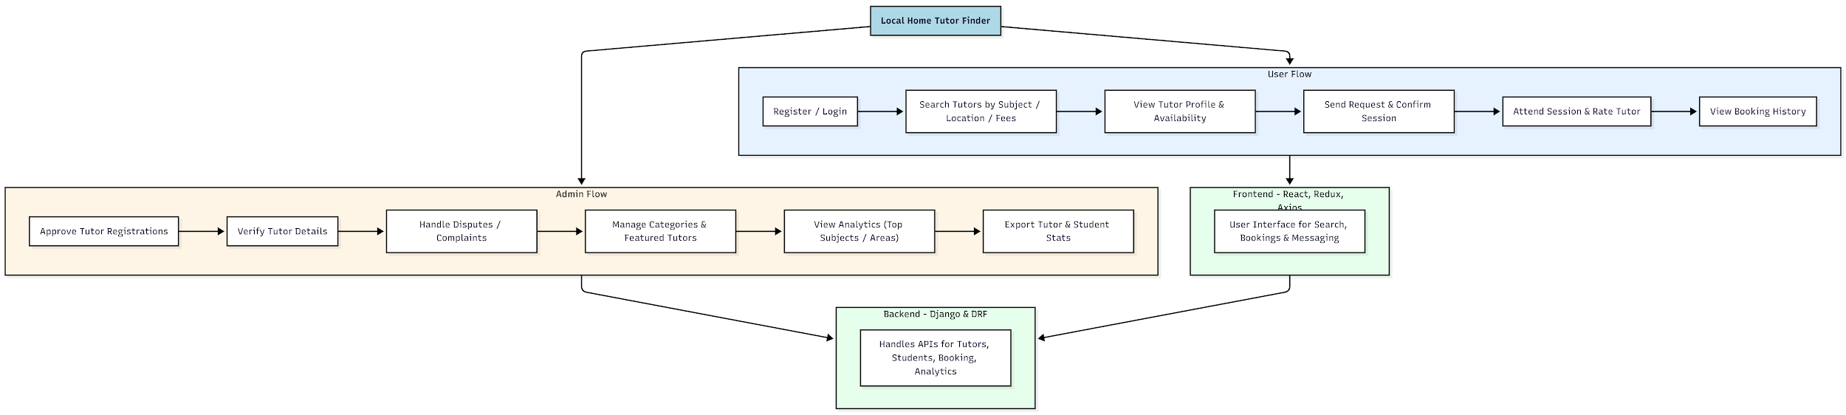

WORKING OF THE PROJECT:
Users begin by registering on the platform and searching for tutors using filters like subject, location, or hourly fees. After reviewing the profile—including qualifications, availability calendar, experience, and reviews—students can send a booking request. Once confirmed, the student attends the session and rates the tutor. All previous bookings and communications are stored for future reference.
Admins regulate the platform by approving tutor accounts, verifying documents, resolving disputes, managing categories, and reviewing analytics to maintain platform quality..

SOFTWARE REQUIREMENT:
- Backend:
  - Python 3.x
  - Django
  - Django REST Framework
  - SQLite/PostgreSQL
- Frontend:
  - Node.js and npm
  - React.js
  - Axios
- Development Tools:
  - Visual Studio Code
  - Postman (for testing APIs)
  - Git/GitHub (for version control)
- Server/Deployment (Optional):
  - Gunicorn, Nginx, or Heroku/AWS for hosting

ADVANTAGES OF THE PROJECT:

• Quick and reliable tutor discovery
• Ability to compare tutors using rich filters
• Verified profiles ensure student safety and quality
• Easy session booking and tracking
• Built-in rating & review system
• Advanced admin controls for better governance
• Dashboard analytics for performance insights
• Improved visibility for freelance tutors

APPLICATIONS OF THE PROJECT:
• Students searching for academic subject tutors
• Parents looking for home tuition help
• Freelance tutors expanding their reach
• Coaching centers offering home-tutor extensions
• Schools outsourcing personalized tutoring

REFERENCES:

- Django REST Framework Documentation — Django Software Foundation. Django Documentation. Available: https://docs.djangoproject.com/
- Django REST Framework. DRF Documentation. Available: https://www.django-rest-framework.org/
- React. React Official Documentation. Available: https://reactjs.org/docs/getting-started.html
- Redux. Redux Documentation. Available: https://redux.js.org/introduction/getting-started
- PostgreSQL Global Development Group. PostgreSQL Documentation. Available: https://www.postgresql.org/docs/
- MySQL. MySQL Reference Manual. Available: https://dev.mysql.com/doc/
- Git. Git Documentation. Available: https://git-scm.com/doc
- Node.js. Node.js Documentation. Available: https://nodejs.org/en/docs/
- Axios. Axios Documentation. Available: https://axios-http.com/docs/intro
- Socket.io Documentation – https://socket.io/docs/

